Probabilistic Settlement Analysis: Main Window

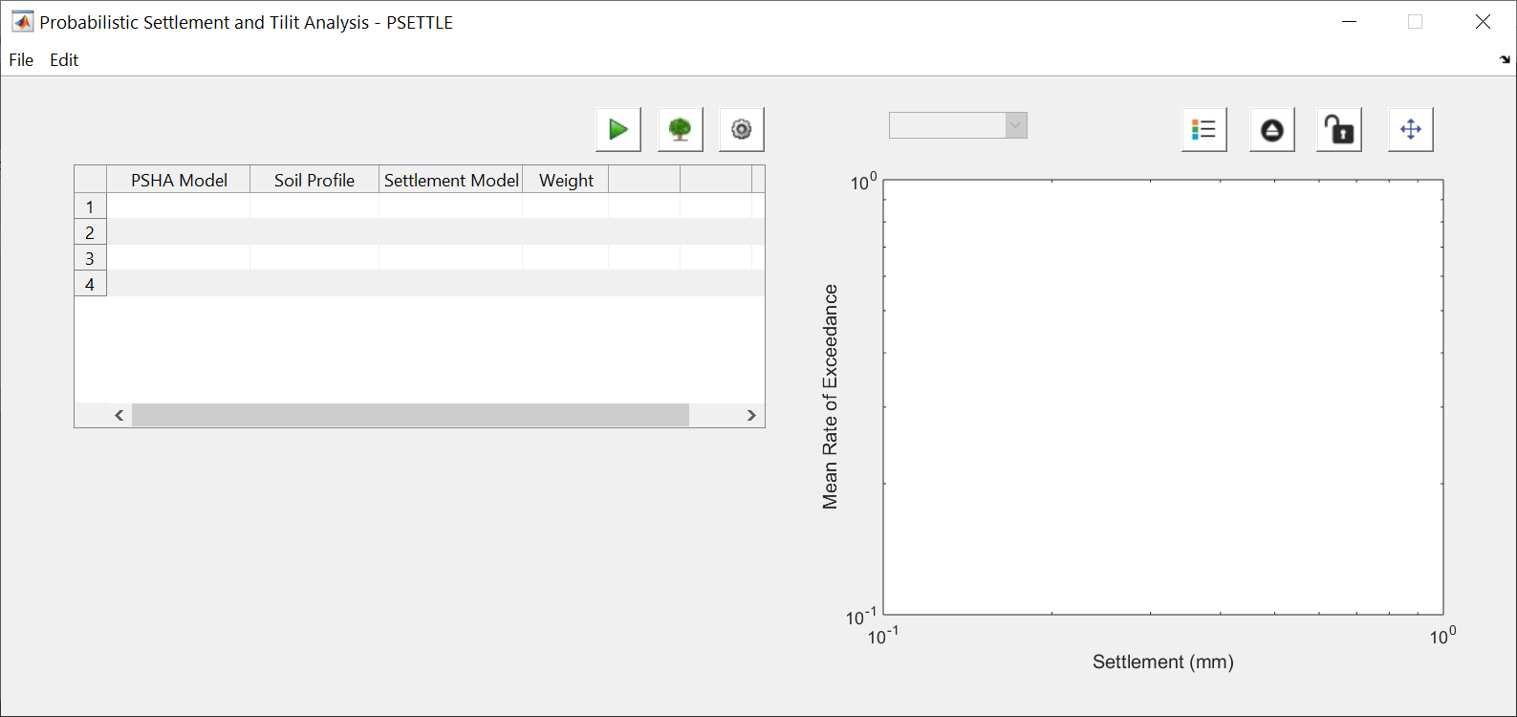

Probabilistic Settlement Analysis: Logic Tree Definition

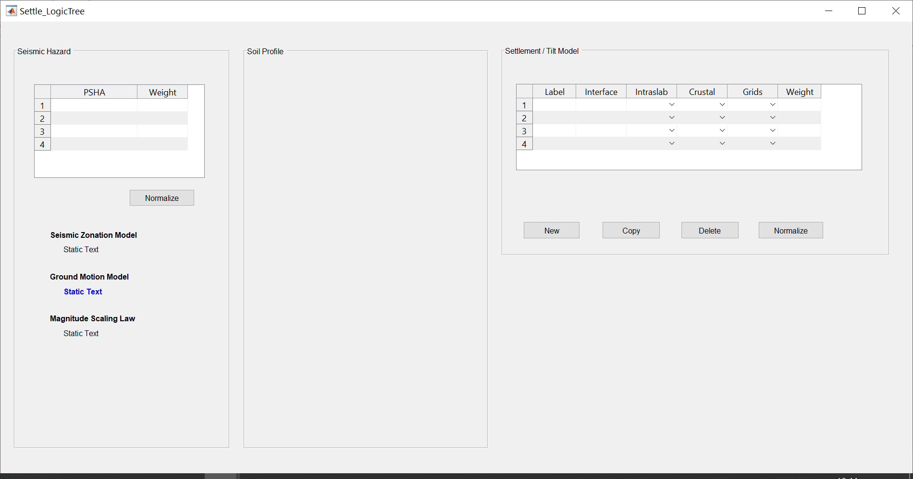

Need your input here

Probabilistic Settlement Analysis: Settlement and Tilt model explorer

